IEEE YESIST12 2025 Grand Finale Report
Date: August 23rd and 24th, 2025
Location: Universiti Kebangsaan Malaysia (UKM), Kuala Lumpur, Malaysia

DAY1

Inaugural Session
The 10th edition of YESIST 12 was inaugurated at the Universiti Kebangsaan Malaysia (UKM), Kuala Lumpur, Malaysia. The event was attended by distinguished guests, dignitaries, volunteers, mentors, participants, and well-wishers who were all inspired by the spirit of innovation.
The event commenced with registration and kit distribution, setting a welcoming and engaging tone as participants connected with one another and prepared for the sessions ahead. The first day unfolded with the initial rounds of project evaluations, where participating teams presented their innovative solutions to panels of distinguished judges. These presentations reflected the very essence of YESIST12—encouraging impactful ideas that address pressing social and environmental challenges across six different tracks of YESIST12 2025. The inaugural ceremony was a grand occasion, graced by Yang Berhormat Senator Saraswathy Kandasami, Deputy Minister of the Malaysian Ministry of National Unity, accompanied by dignitaries, senior academicians, and international experts. The program commenced with the Malaysian National Anthem and a heartfelt Doa Recitation, followed by inspiring addresses. Among them were the welcome address by Prof. Ts. Dr. Faizal Mohamed, an introduction to YESIST12, it’s mission, vision by Dr. Ramalatha Marimuthu, a recorded message from IEEE President-elect Mary Ellen Randall, and the official declaration of the Grand Finale by Yang Berhormat Senator Saraswathy Kandasami. Adding to the significance of the inaugural session was the launch of the IEEE YESIST12 2025 Magazine, the presentation of souvenirs to distinguished Senator, and a group photograph that captured the spirit of the YESIST12 2025..
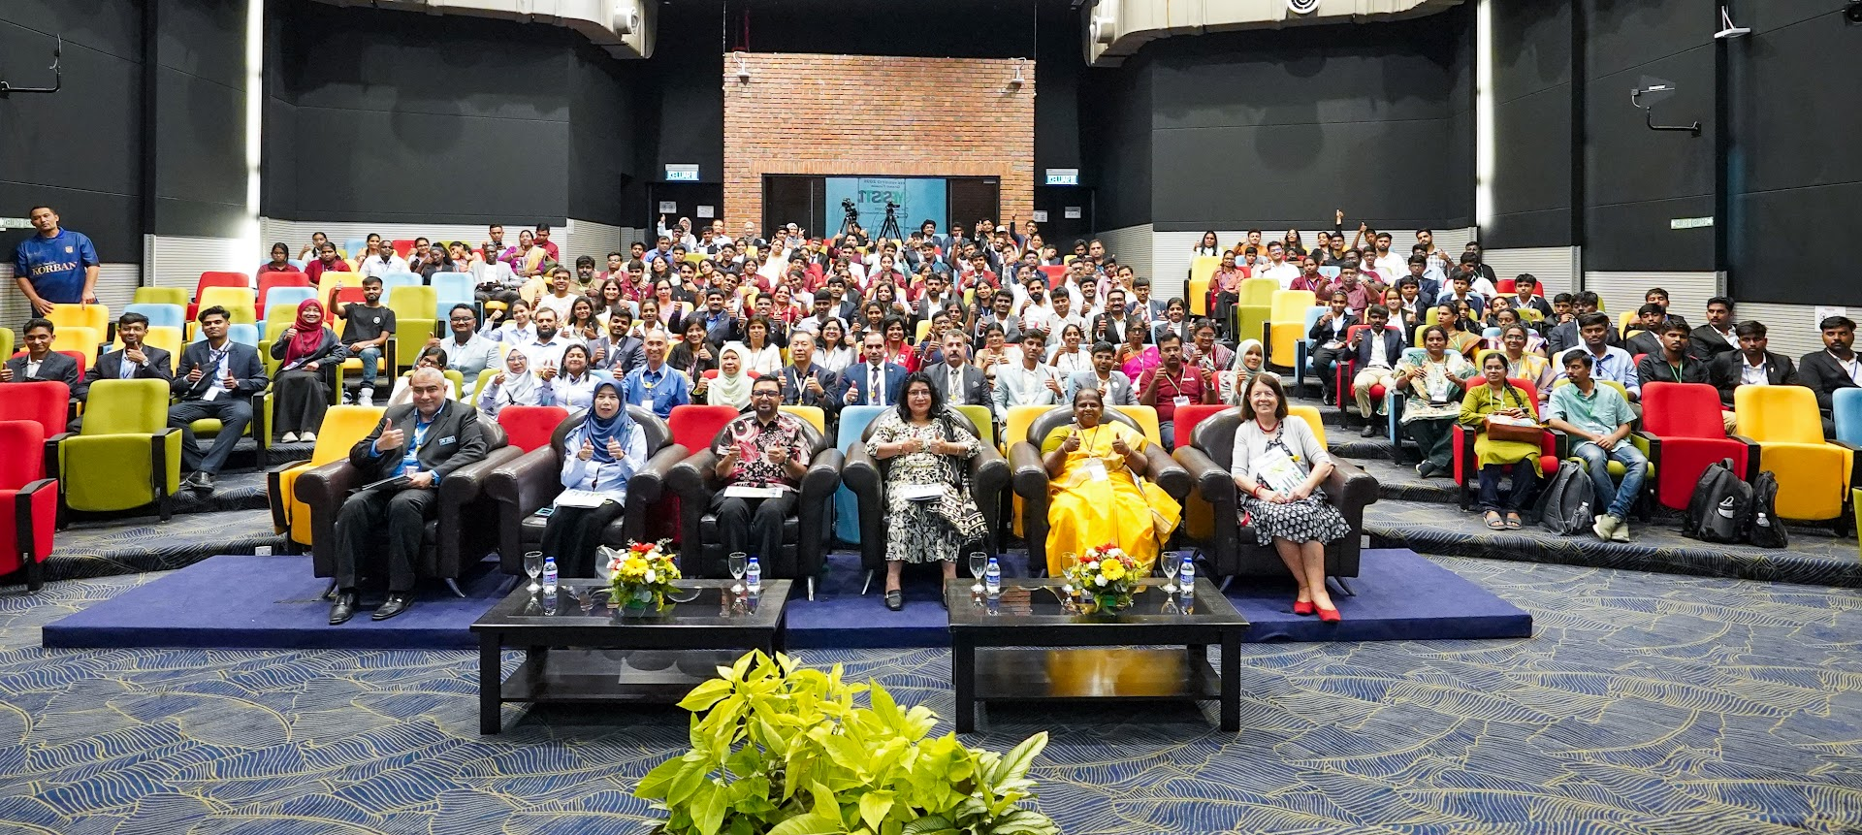
YESIST12 2025 Grand Finale Inaugural Session
Evaluation Sessions:
Followed by the inaugural session, we had evaluation sessions of all the five tracks along with FET100 special evaluations. The
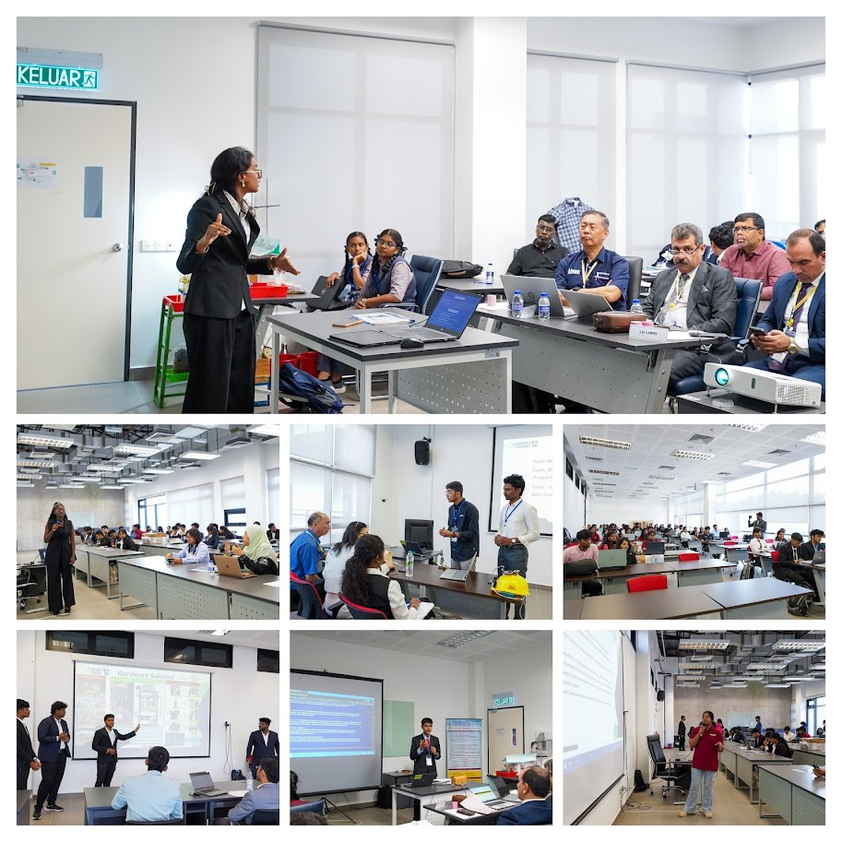

Young Professionals Meetup
Alongside these highlights, Day 1 also featured a Young Professionals Meetup, which brought together young engineers and innovators for meaningful exchanges on leadership, career pathways, and the evolving role of technology in addressing global challenges. This session created an energetic platform for networking, collaboration, and inspiration, rounding off the first day on a note of promise and enthusiasm.
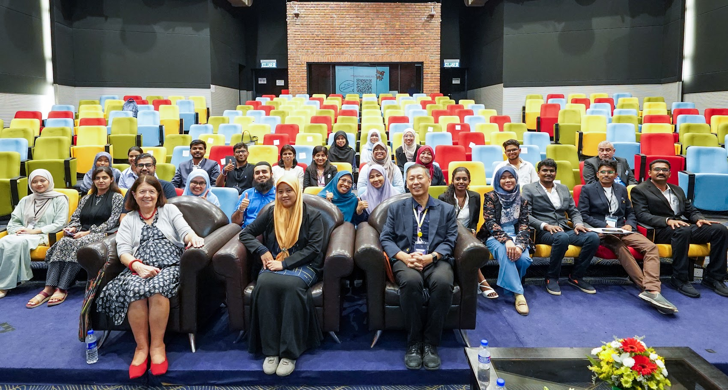

DAY 2
The Day 2 of Grand Finale started with a photoshoot of the delegates and participants.
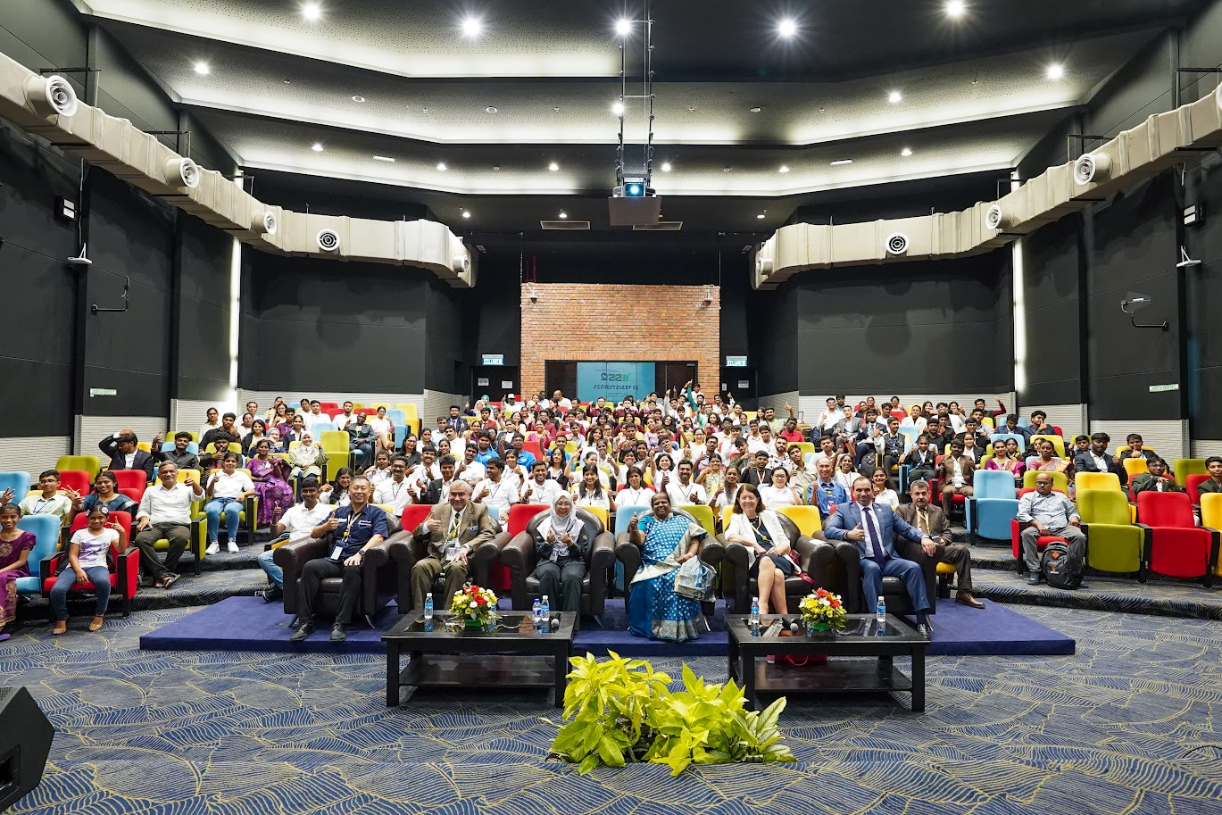
YESIST12 Delegates and Participants

Keynote Sessions:
The initial keynote session was delivered by Er. Nehad El Sherif (IEEE Industry Application Society & Founder and President of MNKYBR Technologies Inc. Canada) on September 3rd, 2023. By sharing his experiences and lessons learned on “What I wish I knew when I was younger”, Er. Nehad El Sherif inspired attendees to push boundaries and explore new possibilities in their own work.
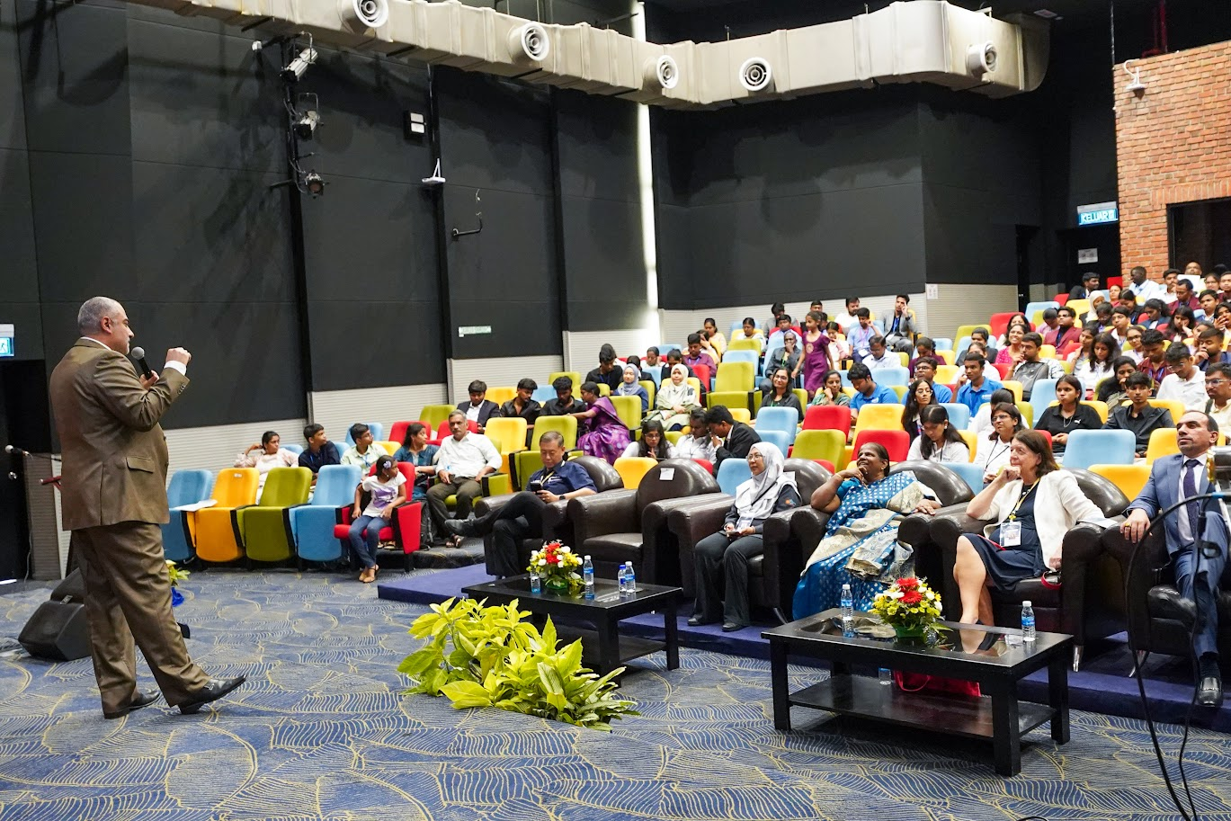
The second keynote session was delivered on the topic “The Power, Beauty and Excitement of Interdisciplinary Research and its Real World Applications” by Bozenna Pasik Duncan (Professor of Mathematics, Kansas University. USA).
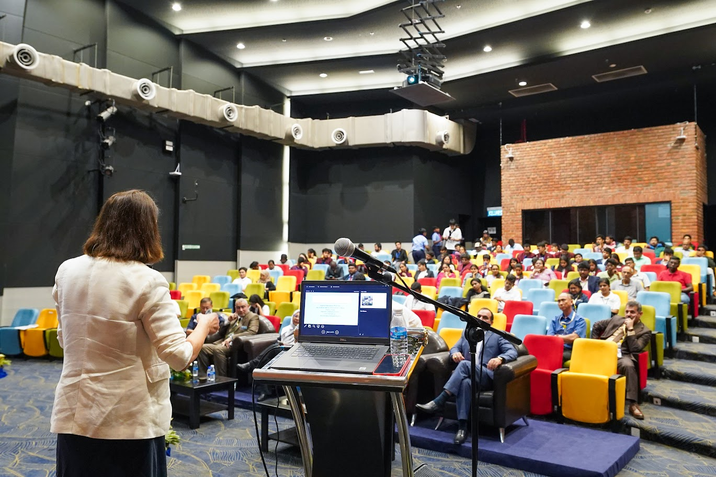
The Keynote session 3 was delivered on “EPICS in IEEE: Connecting Engineering to Community Service” by Rushali Thakkar (EPICS in IEEE Commitee Member & Electrical Engineer, Intercel Energy Solutions B.V, Netherlands)
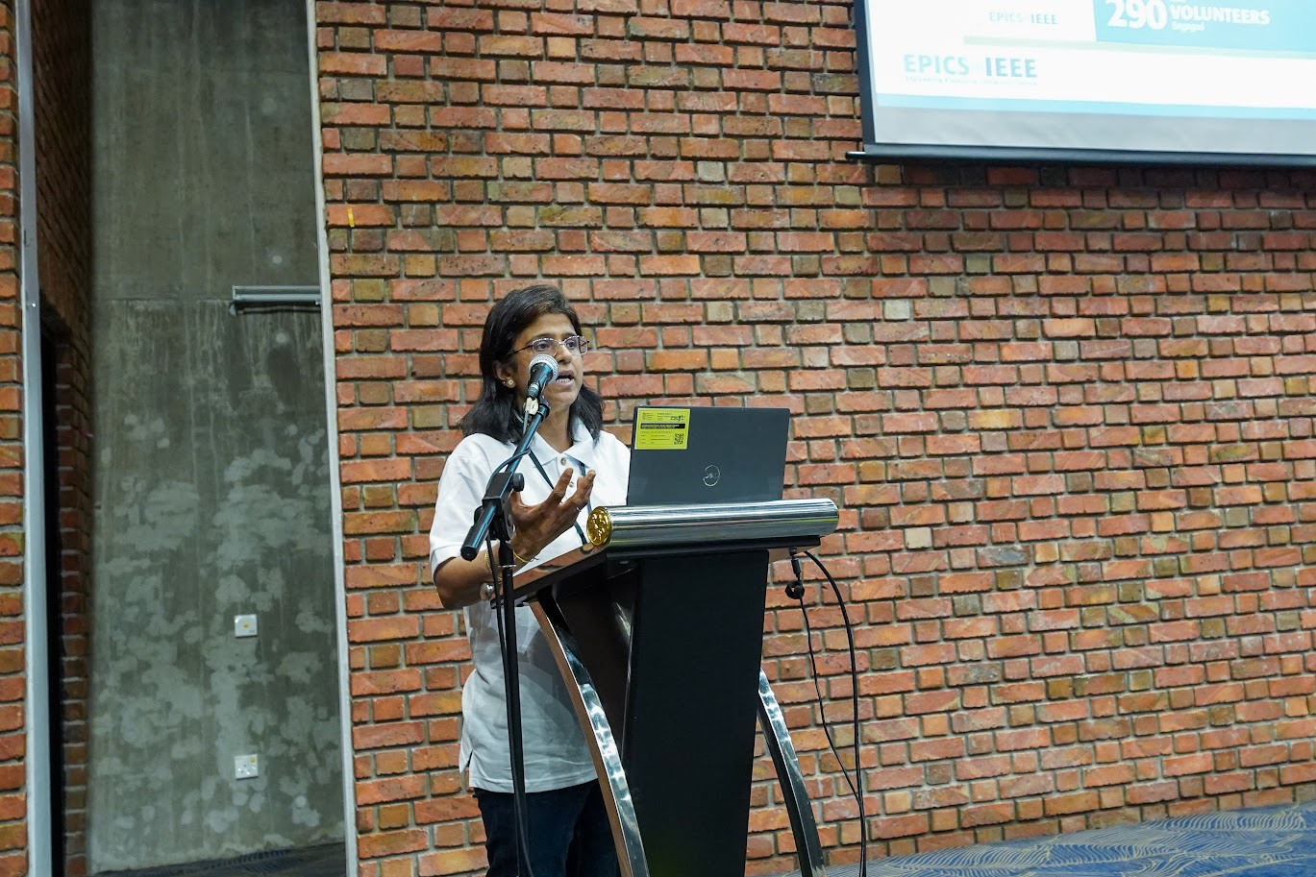
Keynote session 4 was delivered on “Powering Humanity: Sustainable Energy for Social Impact” by Hussain Falih Mahdi (PES HAC & Lecturer at Computer and Software,College of Engineering. University of Diyala, Iraq)
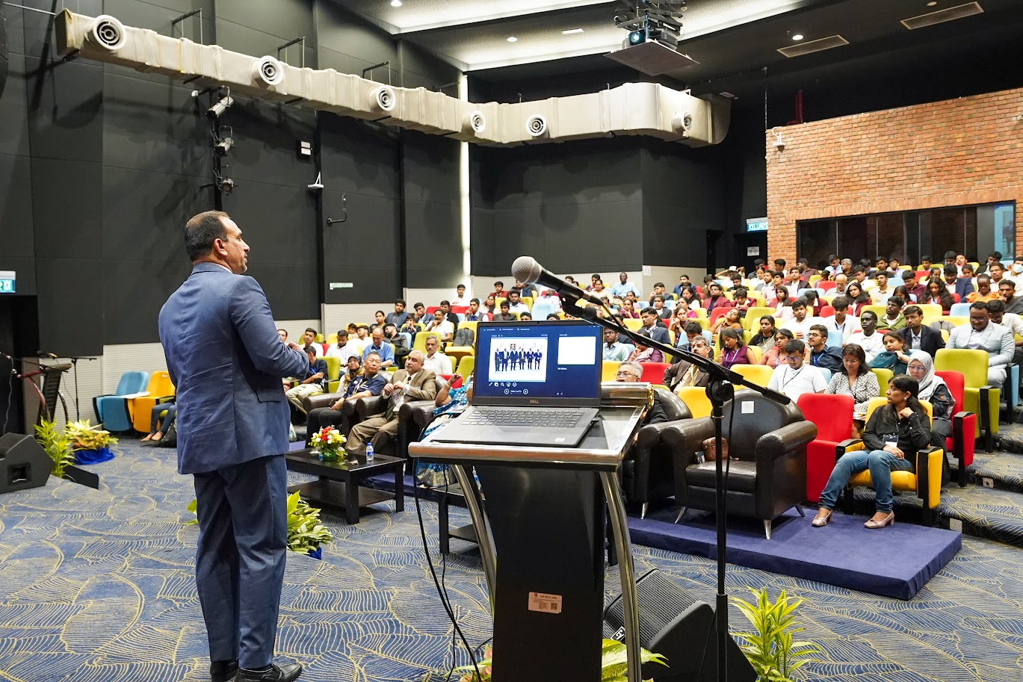
We had an enriching Keynote Session 5 on “Women in Sensors: Empowering Talent in Sensors Domain” by Sangeeta Singh (IEEE Women in Sensors (WiSe), Committee Member & Head Professional Societies,Vardhaman College of Engineering, Hyderabad, India).
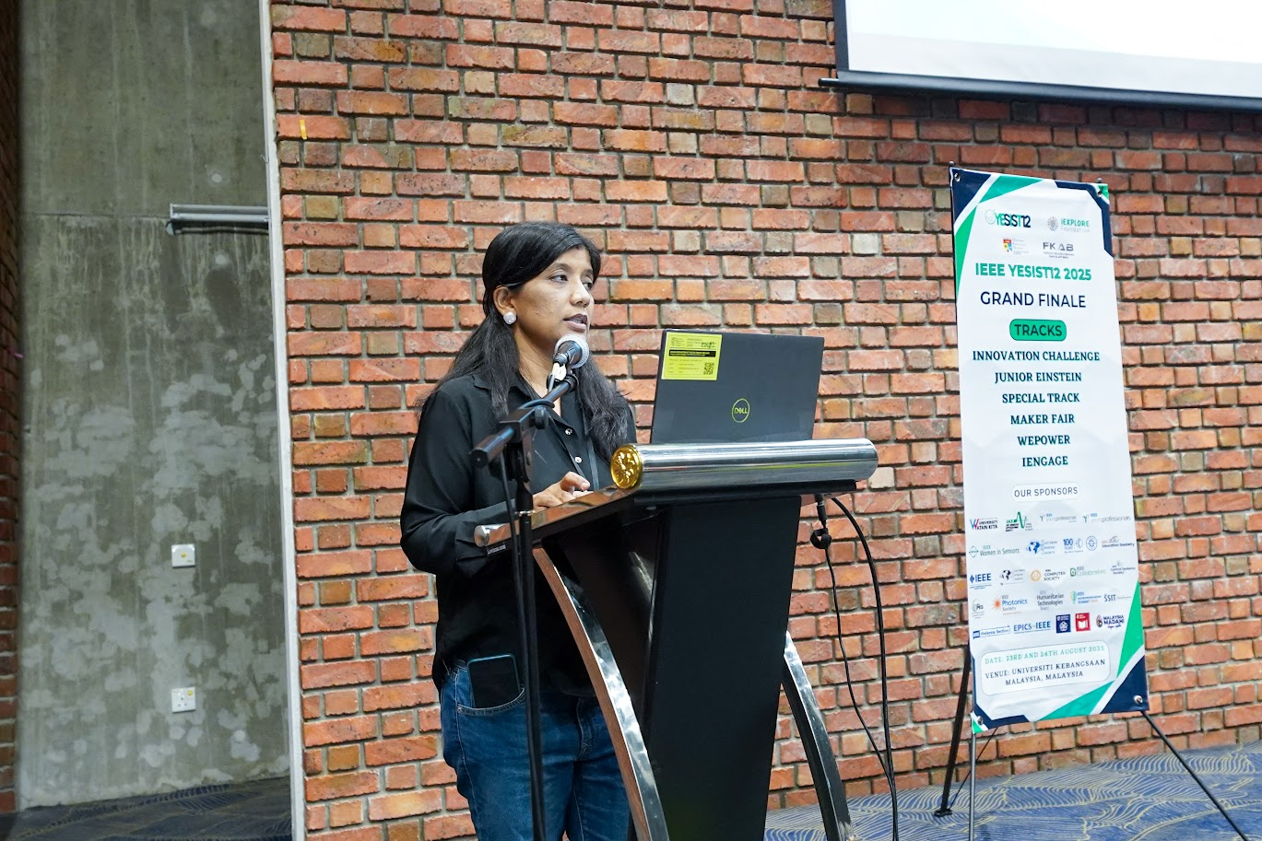
Finally we had Keynote Session 6 on “FET100: Empowering Tomorrow's Innovators with YESIST12 and IEEE EDS” by Susthitha Menon (Associate Professor at the Institute of Microengineering and Nanoelectronics (IMEN), The National University of Malaysia, (Universiti Kebangsaan Malaysia - UKM)

Track Evaluations

TRACK: JUNIOR EINSTEIN
The Junior Track of 2025 was a celebration of exceptional talent and innovative projects from around the world, featuring a total of 25 teams, each showcasing a diverse range of groundbreaking ideas.
- Winner: "Multimodal Communication Device for Deaf-Blind Individuals using Morse Code (Doshwaves) – MORSE MINDS"
- Runner-Up: "Smart Guardian Belt – FutureSafe Collective"
- Honorable Mentions:
"FarmSense"
"Smart Silencer - Emission Detector"
“Smart Reminder For Drinking Water”
“Q'Vault”

TRACK: INNOVATION CHALLENGE
The Innovation Challenge 2025 Track showcased remarkable talent and innovation in a competitive arena. This year's competition drew a diverse pool of participants, with 35 teams, all vying for recognition and honour.
- Winner: "Easy interactive skill enhance"
- Runner-Up: “Innovative PCM Composites for Smart Thermal Management in Electronics & PV Systems"
- Honorable Mentions:
"Smart Tourism Management System for Personalized Travel & Hotel Services"
"AGRIBIMA AI"

TRACK: MAKER FAIR
Moving on to Maker Fair 2025 Track, the event brought together a diverse range of creative minds, with 34 teams participating.
- Winner: "FemEase – Golden Ratio"
- Runner-Up: "Eye-Tracking Based Telehealth Communication System – Team TriFusion"
- Honorable Mentions:
"FarmSense"
Emission Detector"
“Smart Reminder For Drinking Water”
“Q'Vault”

TRACK: SPECIAL TRACK
The Special Track 2025 gathered a diverse group of participants, featuring 36 teams.
- Winner: "Smartphone Application for Early Detection of Liver Disease and Psoriasis Disease through Fingernail Analysis "
- Runner-Up: "RESQSENSE"
- Honorable Mentions:"Wrinkl - Smart on - demand laundry and ironing service for urban convenience"
“ECO-CENTRIC - A Renewable Energy Storage Solution That Converts Heat Energy Into Electrical Energy In A Simplified Way”

TRACK: WEPOWER
The WEPOWER track 2025 brought together a diverse array of innovative projects, featuring 25 teams.
- Winner: "Negizhi Micro-Pyrolyser – Green Guardians"
- Runner-Up: "Umeme Sense – Umeme Sense"
- Honorable Mentions:
"Renewable Solar-powered Supercapacitor for green & Sustainable Hybrid Electric Vehicle System with Machine Learning Algorithm"
TRACK: FET100
The FET100 Track of IEEE YESIST12 2025 concluded successfully with its Grand Finale held at Universiti Kebangsaan Malaysia (UKM) on 23–24 August 2025. The track aimed to foster innovation and creativity among students by encouraging them to develop technological solutions under six futuristic themes aligned with societal needs and global challenges.

- WINNERS :

- Track : Innovation Challenge
Theme:FET Idea Compendium – Innovations Shaping Tomorrow Innovation Challenge
Project Title: FET-Enabled Smart Beehive for Pollinator Protection
Team Name: Strikers

- Track : Junior Einstein
Theme:FET100 and Beyond: Tech-Powered Solutions for a Sustainable Planet – Combatting Climate Change, Conservation, and E-Waste
Project Title: Suvayurja Powering EVs with Earths Oldest Forces

- Track : Maker Fair
Theme:Empowering Young Makers for a Sustainable Tech Tomorrow
Project Title: Intelligent Street Lighting with Automated Fault Detection and Dynamic Energy Management

- Track : WePower
Theme:The Green Switch: Transistors Driving a Clean and Affordable Energy Revolution
Project Title:Solar-Powered Water Quality Monitoring and Purification System for Rural Areas with FET-Based Power Management

- Track :Special Track
Theme:Next-Gen FET Applications for Human-Centric Innovation
Project Title:Integration of Flexible FETs and Self-Powered Energy Harvesting for Wearable Glucose Sensors

- Track :Iengage
Theme:Transistors for Tomorrow: FET Projects for a Greener World
Project Title:Automatic fabric inspection system for textile industry

- Honorable Mentions

- Track : Junior Einstein
Theme:FET100 and Beyond: Tech-Powered Solutions for a Sustainable Planet – Combatting Climate Change, Conservation, and E-Waste
Project Title: Bluetooth Controlled Fire Fighting Bot Using Transistor

- Track : Junior Einstein
Theme:FET100 and Beyond: Tech-Powered Solutions for a Sustainable Planet – Combatting Climate Change, Conservation, and E-Waste
Project Title: AgroDrain-Solar-Powered Smart Excess

CONCLUSION
The IEEE YESIST12 2025 Grand Finale concluded on a high note, leaving an indelible mark on all who participated. The two-day event at Universiti Kebangsaan Malaysia (UKM) was more than just a competition; it was a vibrant convergence of ideas, passion, and global collaboration. The projects presented demonstrated remarkable ingenuity and a shared commitment to addressing some of the world's most pressing challenges.
Beyond the project evaluations, the event fostered a rich environment for learning and networking. The inaugural ceremony, graced by distinguished guests, and the thought-provoking keynote sessions provided attendees with invaluable insights and inspiration. The Young Professionals Meetup and the continuous feedback loop reinforced the event's core mission: to nurture a community of innovators dedicated to creating a better, more sustainable future.
Ultimately, the success of YESIST12 2025 lies in its ability to empower the next generation. It has ignited a spark of innovation, forged lasting connections, and shown that when bright minds unite, technology becomes a powerful tool for positive change. The event served as a testament to the fact that while the finale may be over, the journey of innovation and collaboration has just begun.

